Using Emotional Intelligence to Promote Nonviolence

Kathryn M. Lee, MA

Elisabeth C. O’Bryon, PhD

June 26, 2014 | Trinity College
Building a More Peaceful Connecticut:
Tools, Models and Initiatives that
Promote Nonviolence

ei.yale.edu | ruler.yale.edu
TWITTER: @rulerapproach | FACEBOOK: the RULER approach

The building blocks of emotional intelligence are the 5 RULER skills:
Recognizing emotions in one’s self and others
Understanding the causes and consequences of emotions
Labeling emotions accurately
Expressing emotions appropriately
Regulating emotions effectively

Children with greater emotional intelligence:

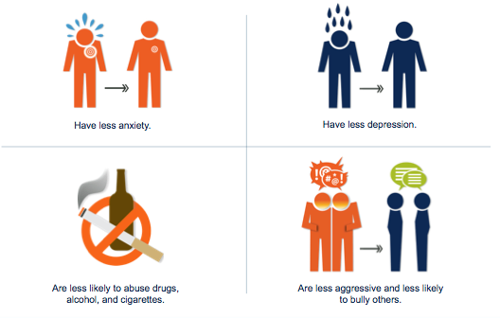

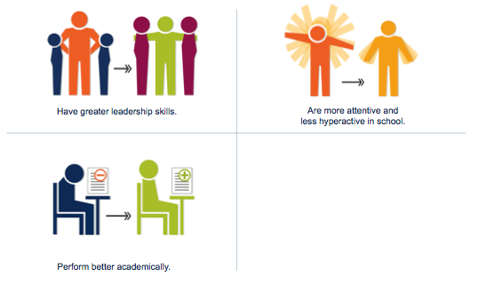

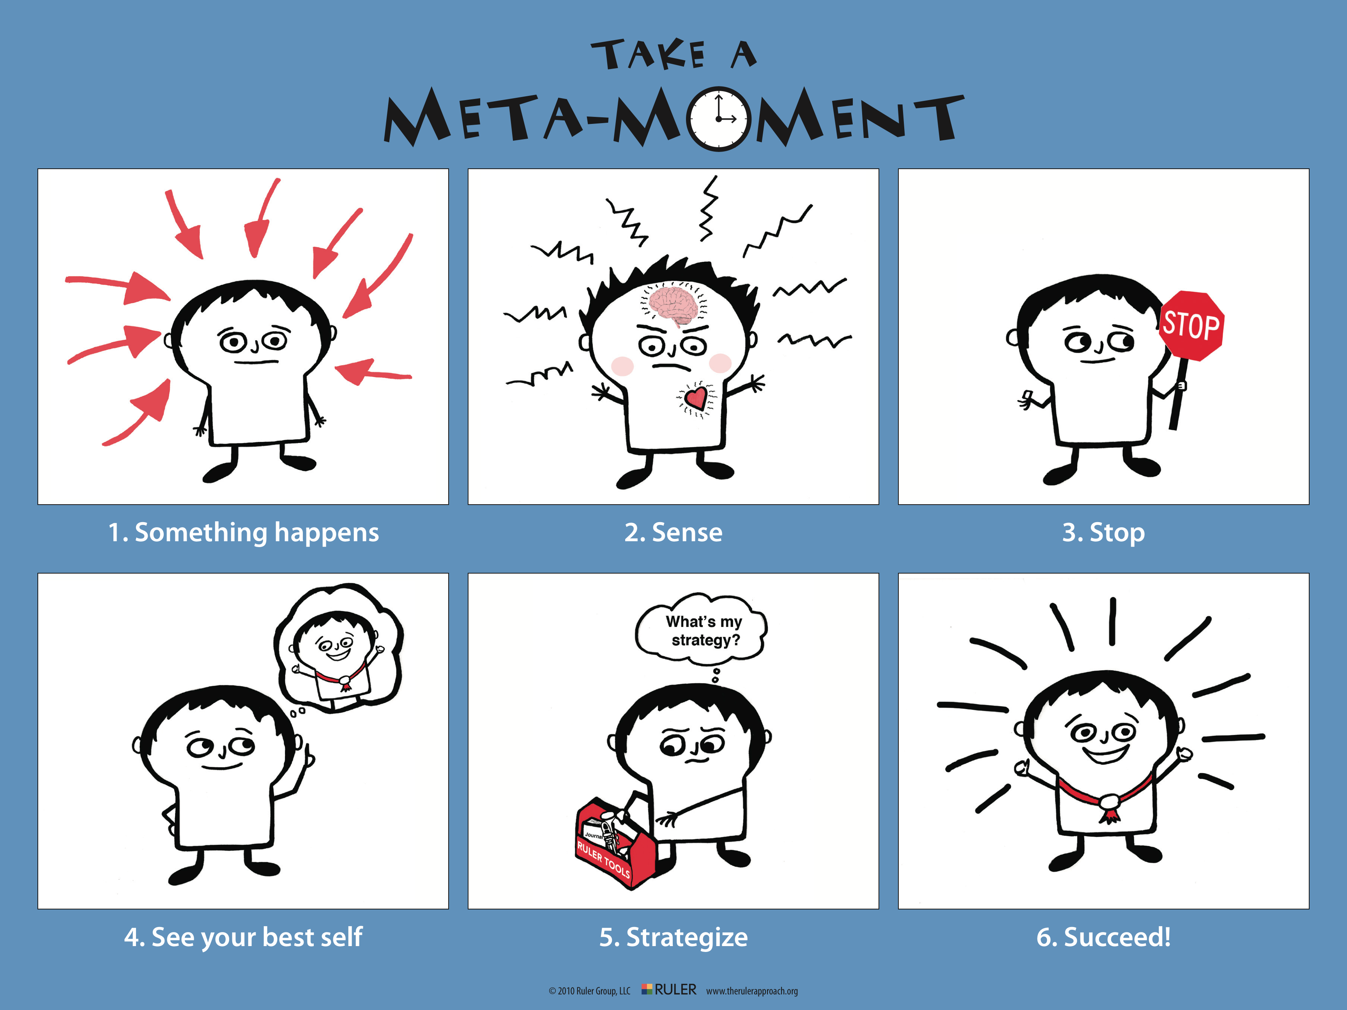

Meta-Moments are a process that children and adults learn to help them expand the “space in time” between an emotional trigger and a response. Adults and children develop strategies to improve their reflective practices and problem solving skills so they can respond effectively to life’s many emotional experiences.

“Between stimulus and response, there is a space. In that space lies our power to choose our response. In our response lies our growth and freedom.”
- Viktor E. Frankl

